MUSEM OF MINERALOGY AND PETROGRAPHY

The Museum of Mineralogy and Petrography at the Department of geology of the Georgian Technical University has existed for seven tens of years. According to mineralogical and petrological exhibits the educational-demonstration Museum of Mineralogy and Petrography may be considered as one of the rich and versatile museums in the Ciscaucasus. There are exhibited metallic and nonmetallic minerals, rock-forming minerals and their paragenic associations, precious and semiprecious stones, facing and building stones from the deposits (and their certain parts) in Georgia, republics of the former Soviet Union and foreign countries. In the Museum of Mineralogy an Petrography there are kept system collections of minerals and rocks nearly from all the world-known deposits and regions, geochemical and genetic collections of minerals and principal minerals of some metals; there are exhibited models of crystalline lattices and of natural crystals of certain minerals.
The Museum is open not only to the students and schoolchildren but to all persons interested in minerals and rocks.
The Museum was founded in 1940 in the building of the Tbilisi Industrial Institute. It occupied only one room where the mineral collections were exhibited in eight small showcases.
In 1952 the Mining Department moved to a specially built new building and the Museum was disposed on the area it occupies at present. It was the beginning of the following development and supplement of the Museum by new samples of various minerals and rocks.
For years the mineral and rock collections were replenished by the centralized way – giving an order to geological expeditions, but lots of samples were presented by former students that worked at famous ore deposits of different countries in the last century. During the field trips the research workers and students of the Department sampled training material, collected interesting samples of minerals and rocks. Geological expeditions and field trainings were carried out not only on the territory of Georgia but in geologically interesting regions of the former Soviet Union, Europe and the USA.
At present the Museum occupies three large halls where the exhibited material is subjected to renovation and reexamination; in the end it will be a unique scientific-educational museum in the Sciscaucasus. There are about 5000 samples thematically distributed in the showcases. The Museum has rich assets of great educational importance; there are kept more then 12 thousand samples of minerals, rocks and ores that are extensively used while carrying out laboratory courses in mineralogy, petrology and geochemistry.
There are 20 showcases in the first hall and there are exhibited about 1500 samples of minerals in them. It is a mineralogical part of the Museum representing the main basis for students in the process of learning the course in mineralogy. The mineral collections are represented by the rich multifarious material comprising samples collected in the previous years and fresh material as well.
The collection of chalcedony group minerals from the Akhaltsikhe ore deposit is considered to be unique.
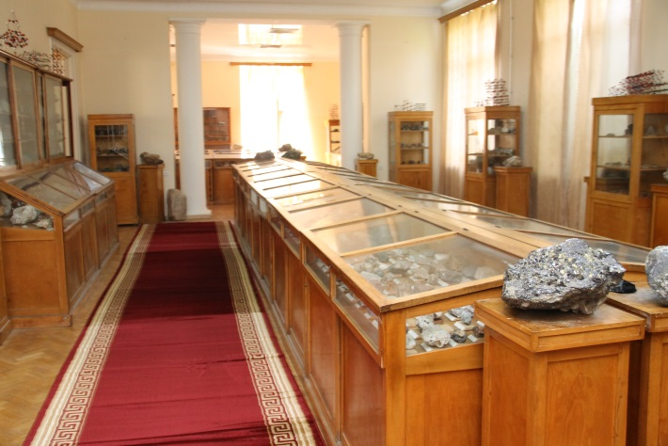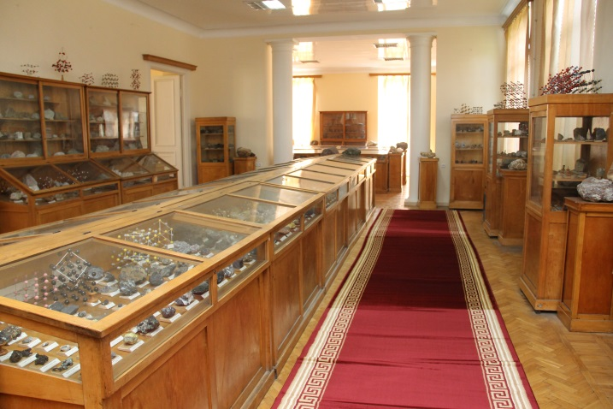
General view of the first hall

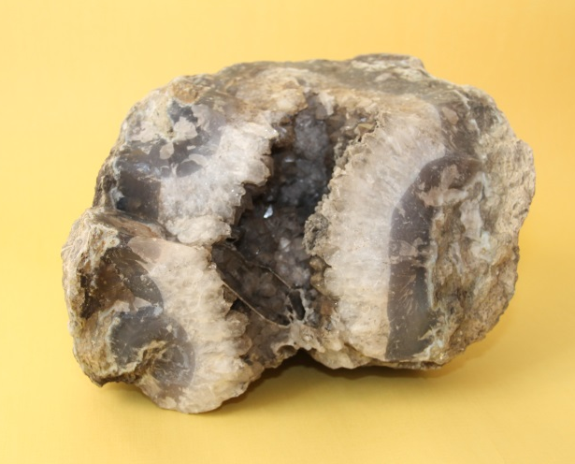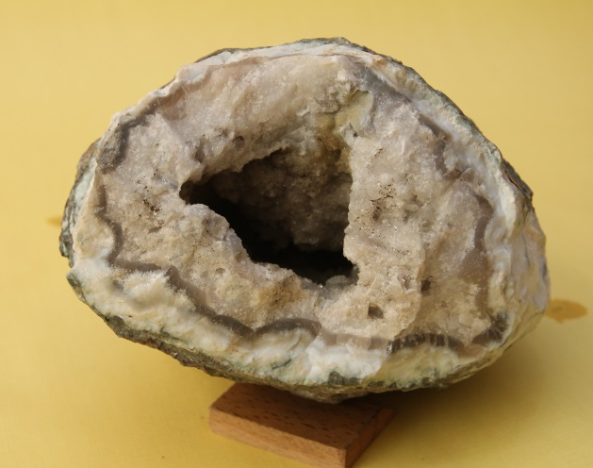
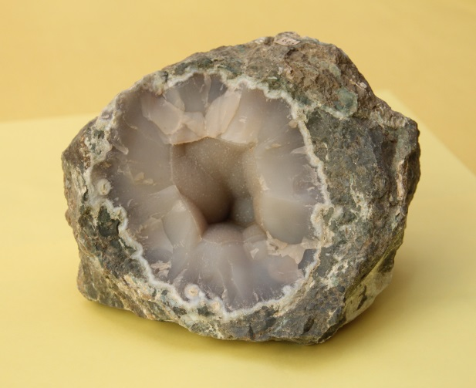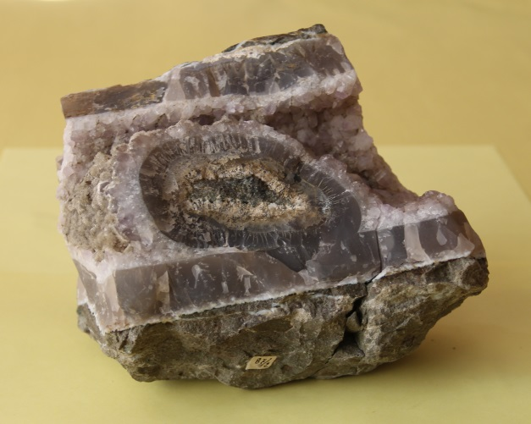

Collection of the quartz-chalcedony group minerals from Akhaltsikhe

In the central showcases of the first hall one can get acquainted with system collections of minerals from native elements to complex silicate class including. In the side showcases mineral collections are distributed according to forms and structure; there are also represented gems and semiprecious stones, quartz group minerals, facing stones, etc. Tops of the showcases are decorated with models of structures of certain minerals.
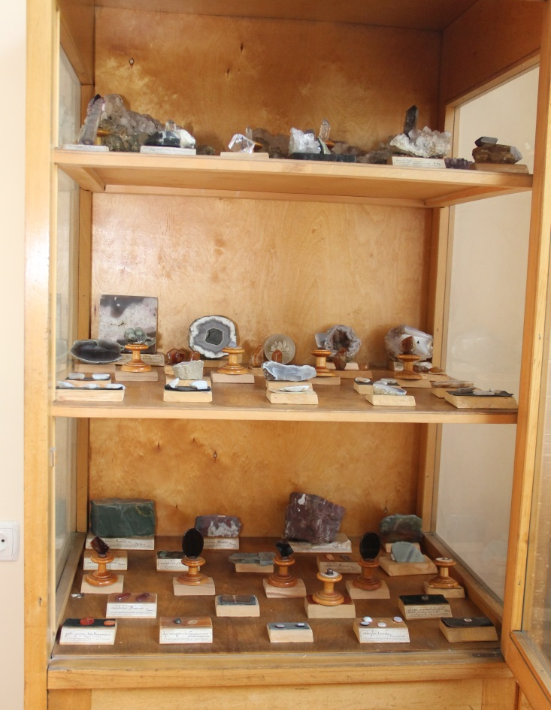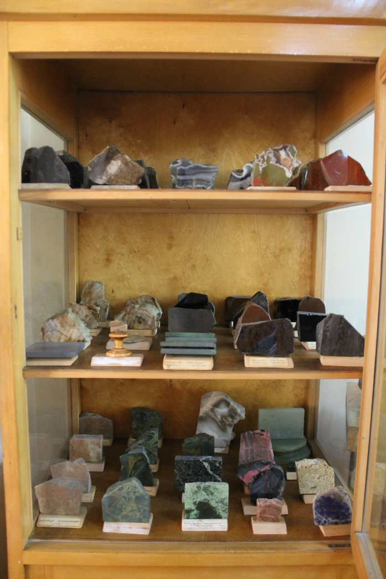
Collections of various minerals
The mineral collections are represented by rich and variegated material comprising the old collections, compiled according to various classifications, and fresh material as well. There are also presented Krantz firm unique collections of minerals compiled according to their crystal forms and physical properties, collections of gems and semiprecious stones, their natural crystalline and process forms. There are widely represented the quartz group minerals from the Akhaltsikhe deposit, sulfide, oxide and sulfate ores of Georgia and various kinds of marble and facing stones, spread in Georgia.
In the second hall there is represented rich thematic material; there are 20 showcases with about 2000 mineral and rock samples exhibited in it; they comprise genetic and system collections, mineral collections according to certain elements. Noteworthy are collections from the deposits of Georgia with paragenic associations of minerals.

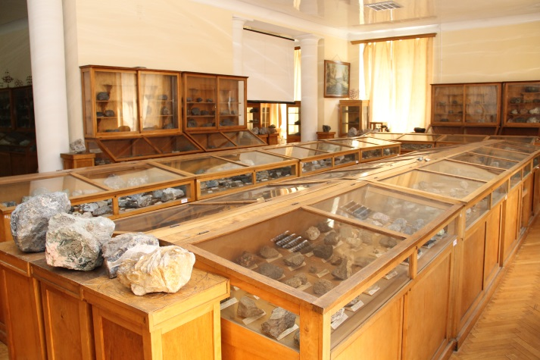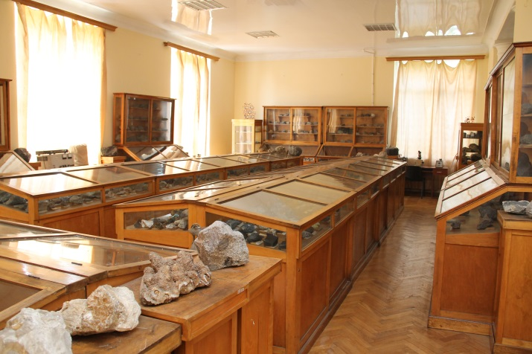
General view of the second hall
In the same hall there is represented rich demonstrative material in lithology that has been compiled on the basis of various collections; especially noteworthy are samples of sedimentary rocks spread in Georgia.
There are 14 showcases in the third hall where there are exhibited about 1500 rock samples.

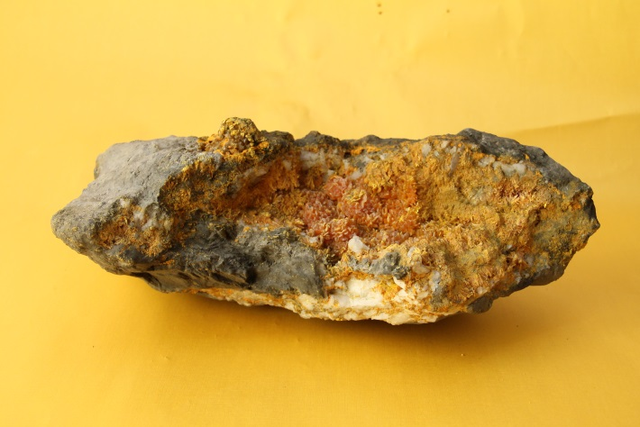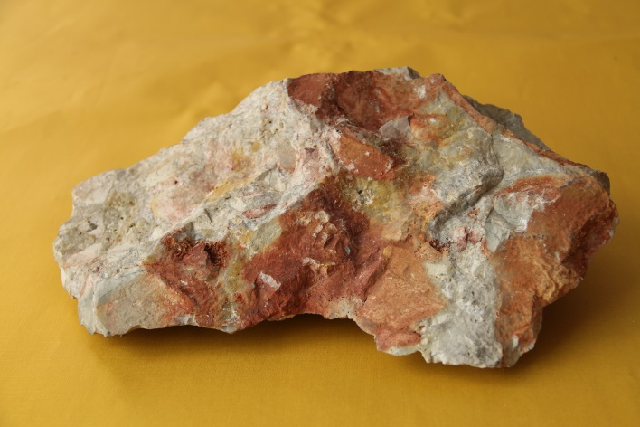
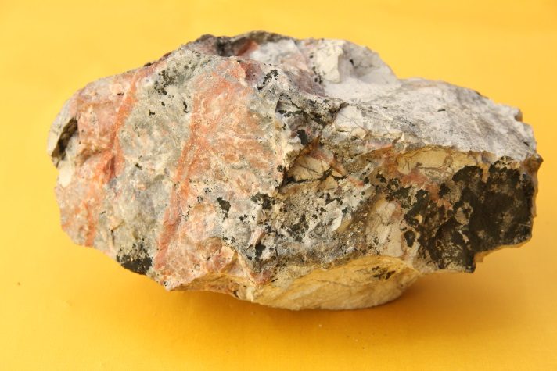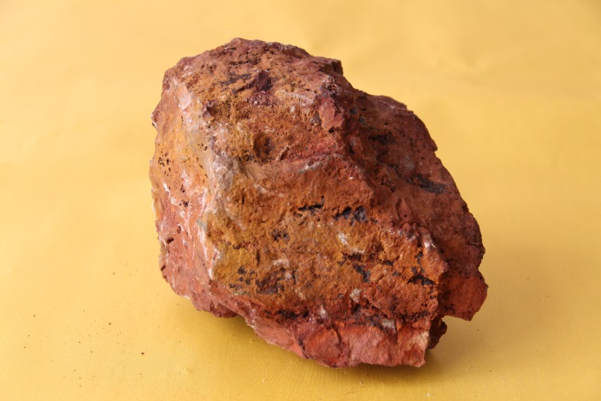
Ores from deposits of Georgia
There are represented system collections of magmatic and metamorphic rocks having been replenished and renewed for many times; rocks from the territory of Georgia occupy special place here. There are separately demonstrated samples of volcanic rocks; there is a vast collection of facing and building stones represented in the form of natural samples and plates of various sizes with polished surfaces where the texture and quality of the rock are well observed.
Noteworthy is that besides the exhibited material, in special stocks depositories there are kept reserve collections that could be changed for exhibits of the various mineralogical-petrological museums of the world.
In the Museum there are also kept thematic collections of doctoral candidates, undergraduates and other research workers.
During their field trainings the students of the Department collect rock and mineral samples that are later sorted and researched in the scientific Center of the Department.
Besides the educational processes the Museum takes part in the activities of the “Saturday school”; there is a special educational program for the pupils of secondary schools as to exceed the limits of their school books and expand and enrich their basic school educational course.

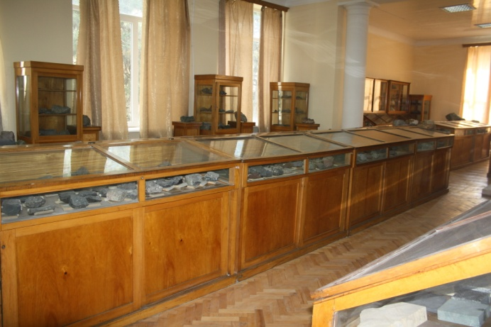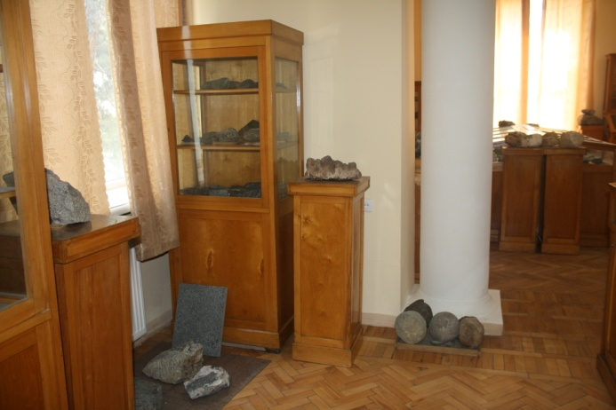
General view of the third hall
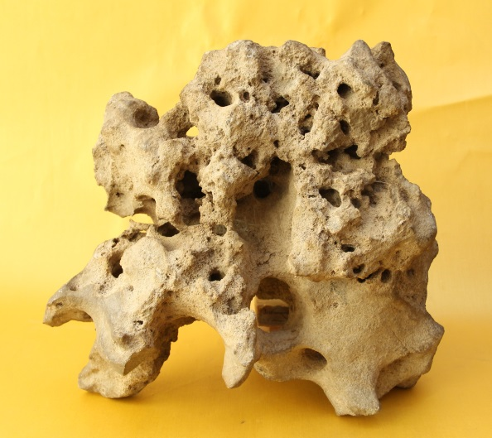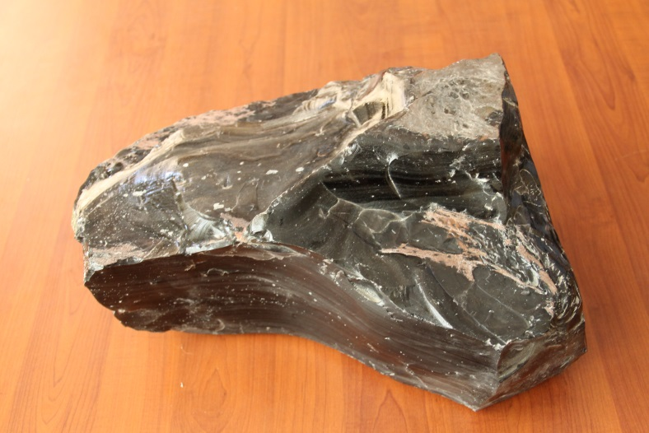

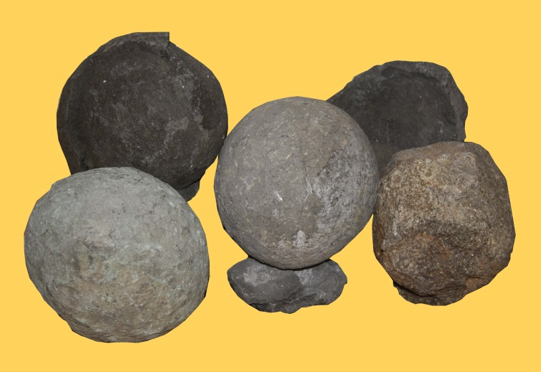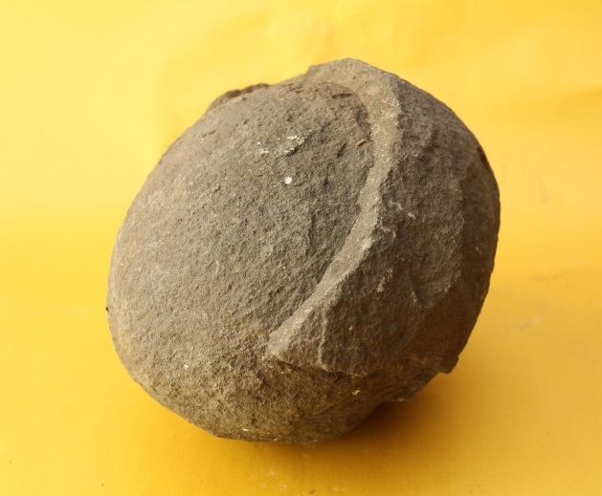

Volcanic formations

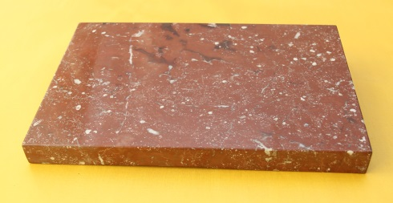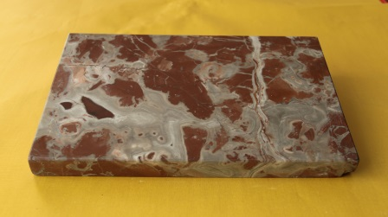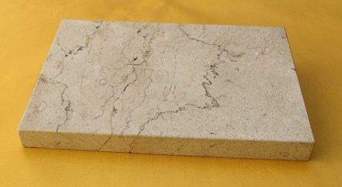

Facing and industrial stones

The “Saturday School” program implies lectures, excursions and discussions on the Earth’s origin, its structure and development history; the pupils can learn about the various geological processes taking place inside the earth (earth quakes and volcanism among them), about the composition of the earth’s crust, rocks and minerals as facing and building material - their peculiarities and spheres of their application; about the use of precious and semiprecious stones in jeweler’s art; they can see minerals – “wanders” of nature. Besides, the pupils learn more about the history of development of animal and vegetable world. The Museum of “General Geology and Paleontology” is also included in the implementation of the “Saturday school” program.
The three museums at the Department of Applied Geology not only popularize the knowledge about minerals, rocks, ores and fossils but infinitely supply the collectors and lots of interested persons with comprehensive information on geological exhibits that are of national and world importance.
The students and pupils, taking practical training course in the museums, can participate in subject seminars and tours regularly conducted for them.

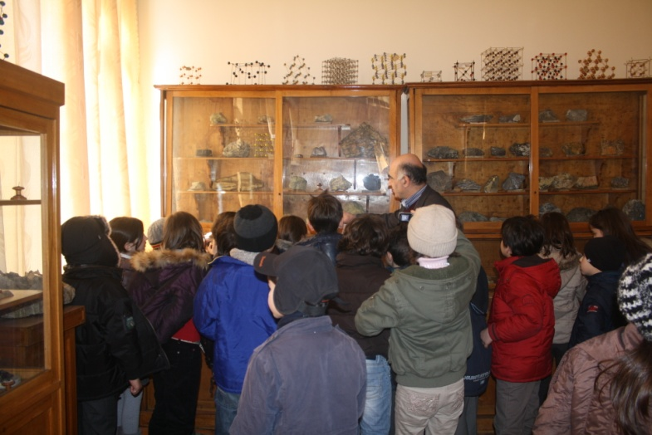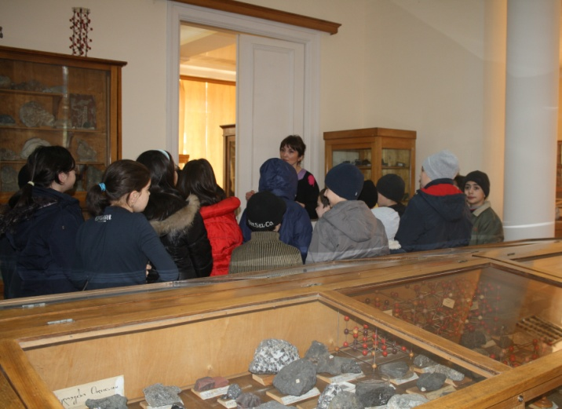
Pupils of Public school are visiting the Museum

At the Museum there starts to function an international geological field camp based on students’ practical field trainings in the Bolnisi and Kazbegi regions, having been carried out for years. The support of the functioning of the Camp will make for the mutual relationships between Georgian and foreign students and - what’s more - for getting profound knowledge.
In recent years the Museum was replenished by students training collections, samples of synthetic colored stones and of their treatment forms. Treatment of semiprecious and synthetic stones is carried out at the Department, in the laboratory for research and treatment of mineralogical material.

